**PET SERVICE WEBSITE**

**Mini Project B Report**

Submitted in partial fulfillment of the requirement of University of Mumbai

For the Degree of

**(Computer Engineering)**

**By**

1. **Vikas Ramprakash Chaurasiya “ID No: TU3F2021091”**
2. **Bhavesh chaudhari “ID No: TU3F2021111”**
3. **Pranit Tanaji Misal “ID No: TU3F2021119”**

**Under the Guidance of**

**Prof. SONALI VIDHATE**



**Department of Computer Engineering**

**TERNA ENGINEERING COLLEGE**

**Plot no.12, Sector-22, Opp. Nerul Railway station,**

**Phase-11, Nerul (w), Navi Mumbai 400706**

**UNIVERSITY OF MUMBAI**



**TERNA ENGINEERING COLLEGE, NERUL,**

**NAVI MUMBAI**

**Department of Computer Engineering**

Academic Year 2020-21

**CERTIFICATE**

This is to certify that the mini project B entitles “Pet Service websites” is a bonafide work of

1. **Vikas Ramprakash Chaurasiya “ID No: TU3F2021091”**
2. **Bhavesh chaudhari “ID No: TU3F2021111”**
3. **Pranit Tanaji Misal “ID No: TU3F2021119”**

submitted to the University of Mumbai in partial fulfillment of the requirement for the award of the Bachelor of Engineering (Computer Engineering).

**Guide Head of Department Principal**

**Prof. Sonali Vidhate Dr. Seema Bhide Dr. L.K Ragha**

**Project Report Approval**

This Mini Project B Report – entitled “**Pet Service website**” by following students is approved for the degree of ***B.E. in "Computer Engineering"***.

**Submitted by:**

1. **Vikas Ramprakash Chaurasiya “ID No: TU3F2021091”**
2. **Bhavesh chaudhari “ID No: TU3F2021111”**
3. **Pranit Tanaji Misal “ID No: TU3F2021119”**

Examiners Name & Signature:

1.---------------------------------------------------------

2.----------------------------------------------------------

Date: ---------------------------------

Place: ---------------------------------

**Declaration**

We declare that this written submission represents our ideas in our own words and where others' ideas or words have been included, we have adequately cited and referenced the original sources. We also declare that we have adhered to all principles of academic honesty and integrity and have not misrepresented or fabricated or falsified any idea/data/fact/source in our submission. We understand that any violation of the above will be cause for disciplinary action by the Institute and can also evoke penal action from the sources which have thus not been properly cited or from whom proper permission has not been taken when needed.

|  |  |  |
| --- | --- | --- |
| **Vikas Chaurasiya** | **“ID No: TU3F2021091”** | --------------------------- |
| **Bhavesh Chaudhari** | **“ID No: TU3F2021111”** | --------------------------- |
| **Pranit Misal** | **“ID No: TU3F2021119”** | -------------------------- |

Date: _____________________

Place: _____________________

**Acknowledgement**

We would like to express our sincere gratitude towards our guide **Prof. Sonali Vidhate**, Mini Project Coordinators **Prof. Dr.Sandeep Raskar** for their help, guidance and encouragement, they provided during the project development. This work would have not been possible without their valuable time, patience and motivation. We thank them for making our stint thoroughly pleasant and enriching. It was great learning and an honor being their student.

We are deeply thankful to **Dr. Seema Bhide (H.O.D Computer Department)** and entire team in the Computer Department. They supported us with scientific guidance, advice and encouragement, they were always helpful and enthusiastic and this inspired us in our work.

We take the privilege to express our sincere thanks to **Dr. L. K. Ragha**our Principal for providing the encouragement and much support throughout our work.

|  |  |  |
| --- | --- | --- |
| **Vikas Chaurasiya** | **“ID No: TU3F2021091”** | --------------------------- |
| **Bhavesh Chaudhari** | **“ID No: TU3F2021111”** | --------------------------- |
| **Pranit Misal** | **“ID No: TU3F2021119”** | -------------------------- |

Date: _____________________

Place: _____________________

**Index**

|  |  |  |
| --- | --- | --- |
| **TABLE OF CONTENTS** | | |
| **Sr. No.** | **Title** | **Page No.** |
|  | **Abstract** | **1** |
|  | **List of Figures** | **2** |
|  | **List of Tables** | **2** |
| Chapter 1 | Introduction   * 1. Sub chapter   2. Sub chapter | 3 |
| Chapter 2 | Problem Statement | 4 |
| Chapter 3 | Literature Survey | 5 |
| Chapter 4 | Design and Implementation | 6 |
| Chapter 5 | Results | 10 |
| Chapter 6 | Conclusion and future work | 22 |
|  | Reference | 23 |

## Abstract

This project is a website which can provide basic info about to care and treat their pet and also provide all related products that a pet owner would need.Indian people are increasingly attached to their pets with animals such as dogs, cats and birds often regarded as part of the family. The concept of owning pets and taking care of them is a very urban phenomenon in India. The growth of the market therefore is largely dependent on the pace of urbanization; the infrastructure changes of the past two decades signal a very positive and rapid movement here. The Indian consumers idea on spending money on buying pets, pets products and pets services is slowly giving way to the feeling of pet humanization and sensitization, trends well demonstrated by the rapid rise in adoption rates of pets.

Many economic experts believe that the pet industry is one of the most stable industries around the world. Some pet-related products and various supplies, do not fare quite as well, but overall, the industry tends to hold up. This is thought to be partly because people see their animals as an extension of their families. There exist vast opportunities for sale of Pets, Pet Products and Services Industry to boost up in India in rear future.

**List of Figures**

|  |  |  |
| --- | --- | --- |
| **Sr. No.** | **Name of Figure** | **Page No.** |
| 1 | Webpage navigation | 6 |
| 2 | Admin privilege | 7 |
| 3 | Database Schema | 8 |

**List of Tables**

|  |  |  |
| --- | --- | --- |
| **Sr. No.** | **Name of Table** | **Page No.** |
| 1 | Tbl_order | 9 |

**Chapter 1**

**Introduction**

Now a days,almost all the information are found on internet in form of websites.There are all types of websites on internet which user browse to gather information.Websites are also easily accessible to people of all age group,which makes website very useful to spread information.we have created website to make use of its easy accessibilty feature.This project is an interactive website used for online shopping and getting relevant information about pet and hygiene.Online shopping is the process whereby consumers directly buy goods orservices from a seller in real-time, without an intermediary service, overthe Internet. It is a form of electronic commerce.

In todays time,owning pets ahve become a trend but new owner faces difficulty in taking care of their pets.This website comes in picture to solve this particular problem.A pet service website can provide a major help to struggling new owners of pet.They can get variety of pet foods along with their decscription which helps them to choose accurately as well as various videos from experts teaching them how to take care of hygiene as well as diet of their pets.

This project involves a admin panel from where administrators of the website can manage category,items,orders using his privileges.Administrator can add,delete or update products in the website.Sign up and login functions are provided for new user to get registered.Users will be required to sign up to place order.User can see their orders in the order button at the top.

**Chapter 2**

**Problem Statement**

* 1. **Problem statement**

Pets are part of our everyday lives and part of our families. They provide us with companionship and also with emotional support to reduce our stress levels, sense of loneliness and help us to increase our social activities positive emotional development. In return the owner need to take care of their pet the best they can.To help such owner to continue having a loving bond by helping them provide all basic neccessities,this pet service website was developed.

We wanted to create a simple website to help everyone with a pet to get easy access to all the neccessary knowledge as well as products.

* 1. **Objectives**

The study is designed with the following objectives:

1. To provide a fast as well as reliable service related to pet care.

1) To study the various opportunities evolved in the pet industry.

2) To comprehend the utilization of various factors behind pet Industry.

**Chapter 3**

**Literature Survey**

1. [Optimization of column width in website layout[2]](https://ideas.repec.org/a/eee/ejores/v226y2013i3p592-601.html)Marszałkowski, Jakub & Drozdowski, Maciej 2013 Cutting, Packing,Column widths Cutting, Packing,Column widths How much the column widths affect resizing and consequentially the loading time. Column widths affect advertisement placement, affecting load times.
2. [Color Your Website: Use of Colors on the Web](https://link.springer.com/content/pdf/10.1007/978-3-540-73289-1_16.pdf) Irina Kondratova and Ilia Goldfarb 2007 Color preferences, color theory, cultural user interface, usability. This study is carried out via an automated “cultural audit” of a large number of websites from different countries. To search for correlation between color theory and cultural markers Along with some colors (hues) used universally across the multitude of cultures, there are some preferred country-specific color palettes

**Chapter 4**

**Design and Implementation**

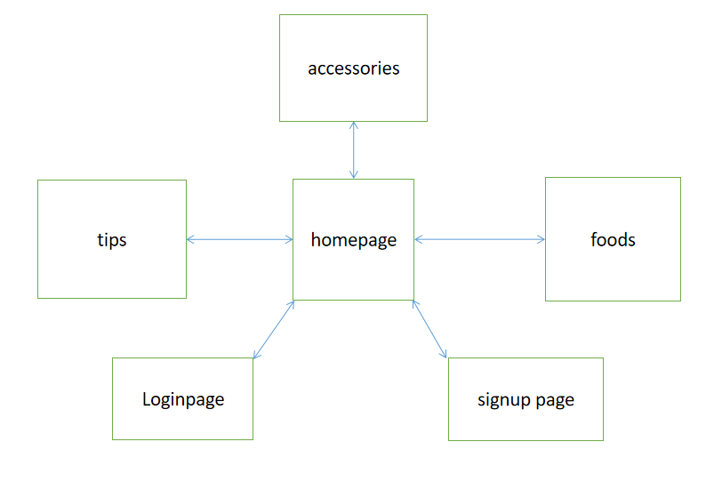

1. Main site
2. Front end

The front of the website is created using html and css.Html gives the basic skeleton which is then designed using css.The front end includes a homepage ,category page ,foods page,accessory page and a tips page.Login and signup ares also created for users

1. Backend

The backend of the site is created using php to connect to the database where information of products are stored .The info of products are displayed in pages from where user can order.After clicking he order button information of the user and product will be stored in he database.

1. Admin panel
2. Front-end

Admin panel include mange admin,manage food,manage accessory,manage order nad customer details page which is created using html and css

1. Backend

Backend is done using php.admin panel has master control of the database.Admin can add,delete and update the content to be displyed on the website.

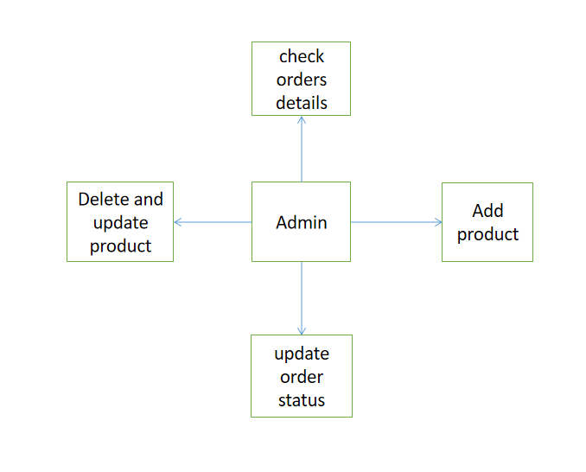

Admin has the privilege to add new product and update the products.Admin can also view customers order details and update the delievery status on the product.

1. **Datebase**

Pet_order database is created with many table to store info about products ,admin and customer.

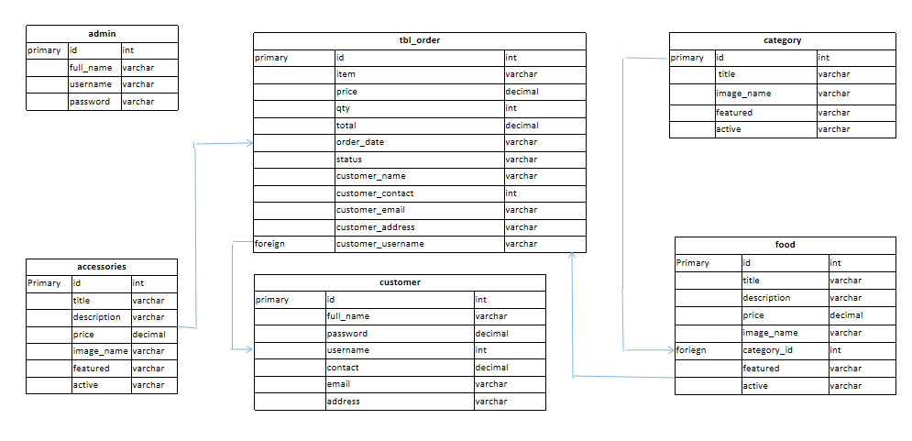

The database has many table to store various types of info about ctaegory and products.

It has tables with name admin,customer,category,food,order and accessories to store the relevant data required to run the website.

1. **Order**

|  |  |  |
| --- | --- | --- |
| tbl_order | | |
| primary | id | int |
|  | item | varchar |
|  | price | decimal |
|  | qty | int |
|  | total | decimal |
|  | order_date | varchar |
|  | status | varchar |
|  | customer_name | varchar |
|  | customer_contact | int |
|  | customer_email | varchar |
|  | customer_address | varchar |
| foreign | customer_username | varchar |

The table for storing order info includes information about the product its price and quantity as well as info about the customer who made the order.customers name,address,contact,email are stored in the order table to uniquely identify customers that are making order.

**Chapter 5**

**Results**

**1)Homepage**

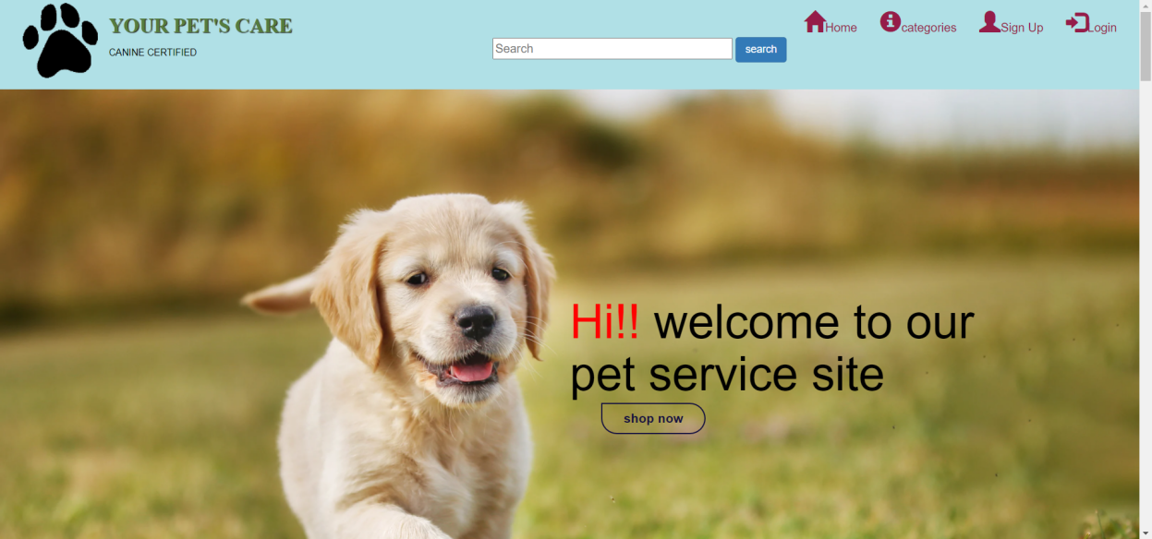

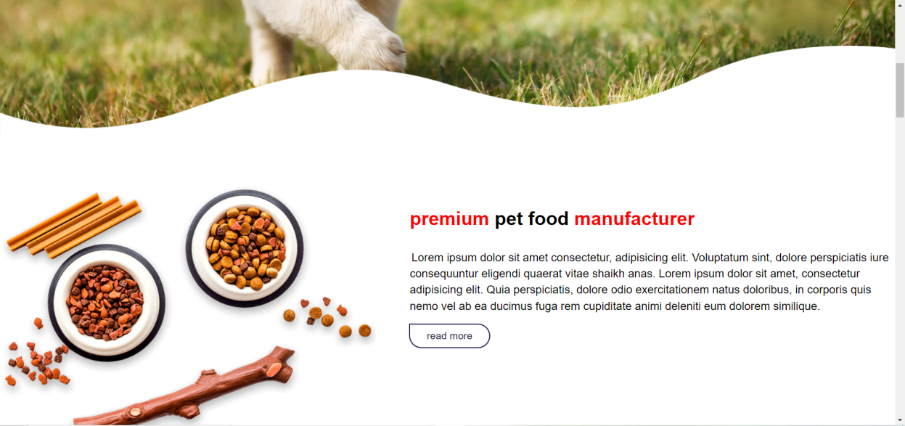

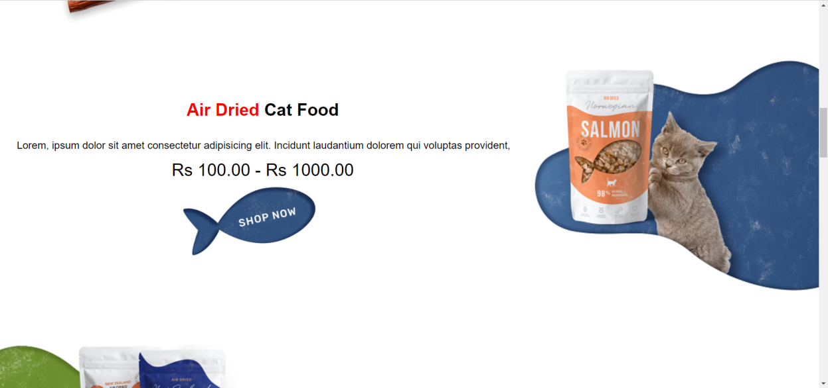

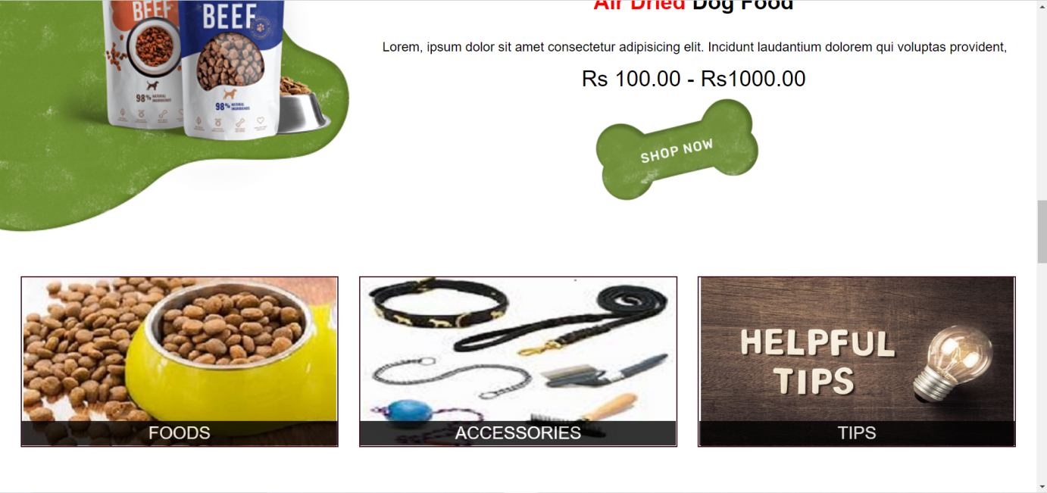

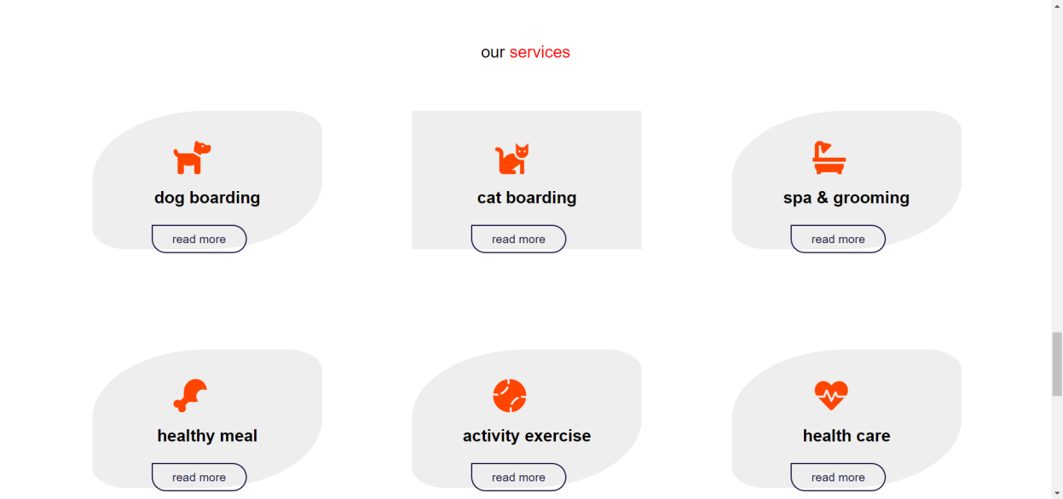

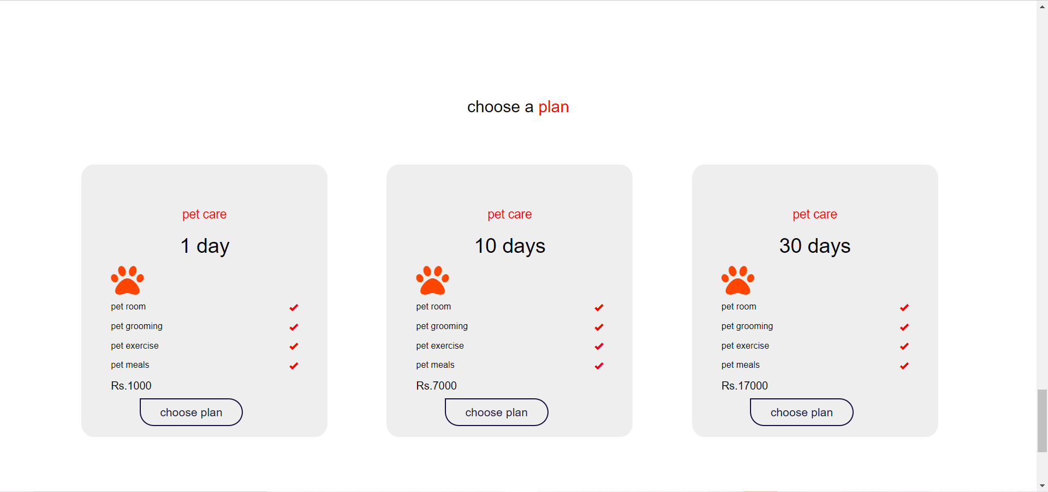

**

1. Foods

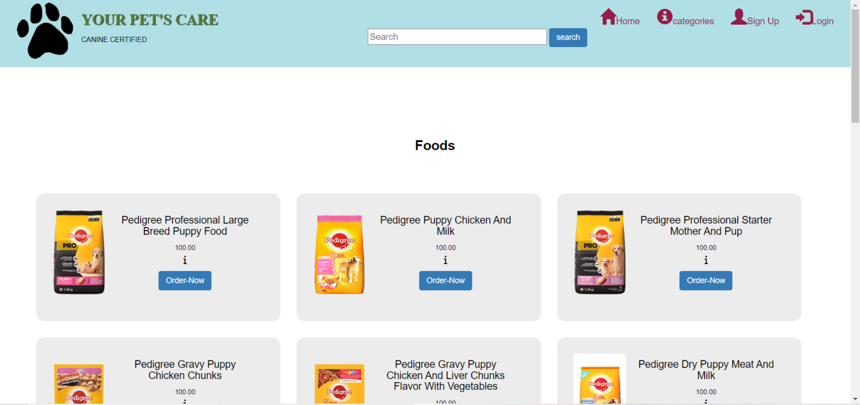

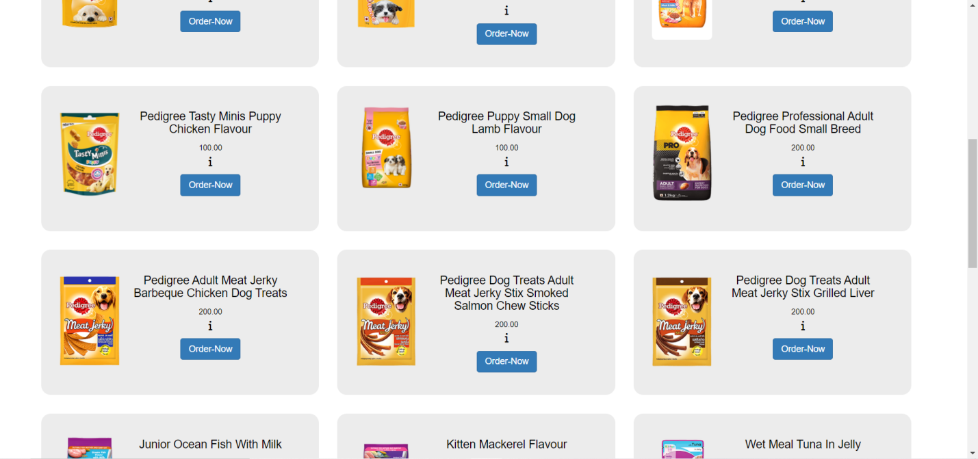

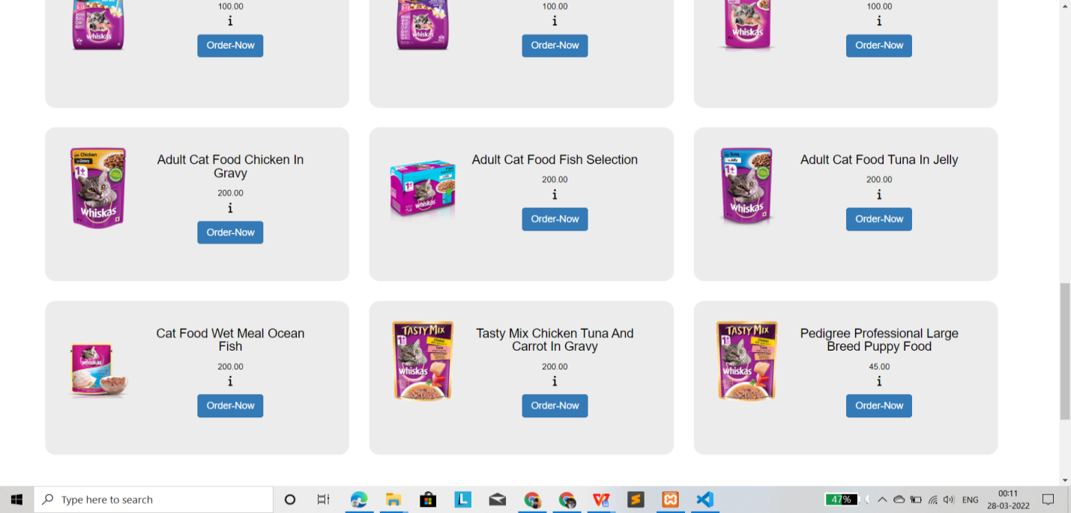

1. Categories

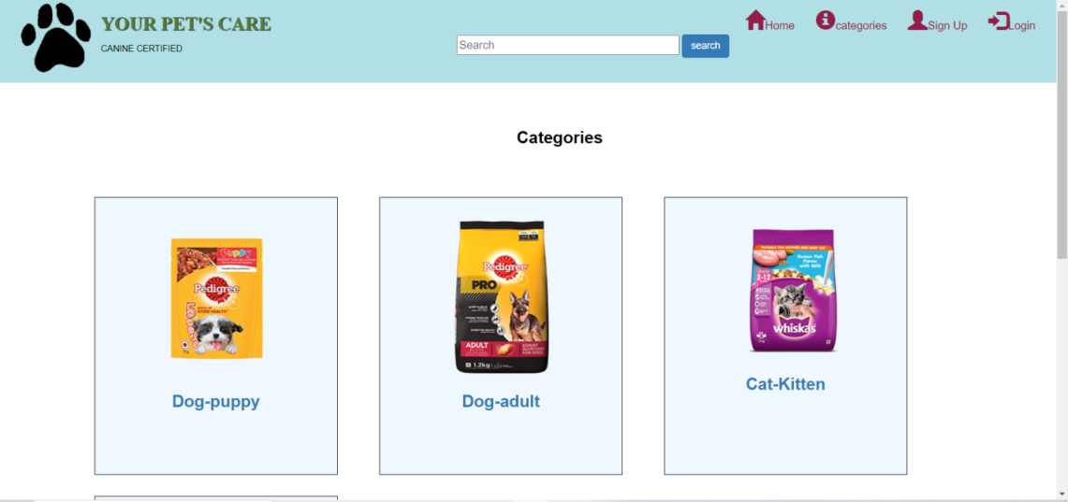

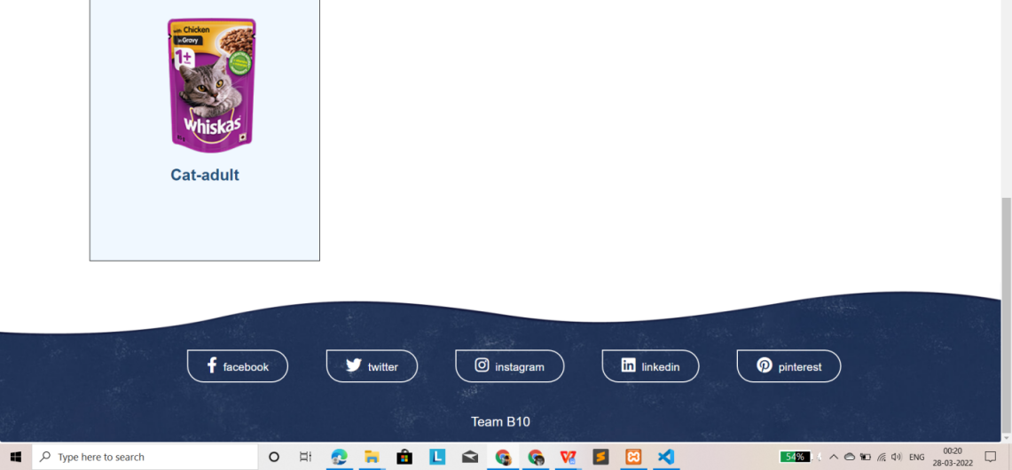

1. Customer

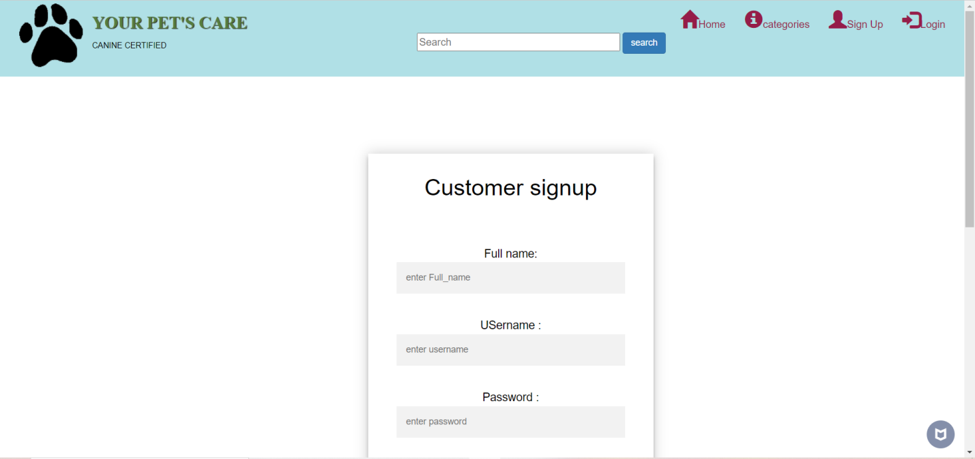

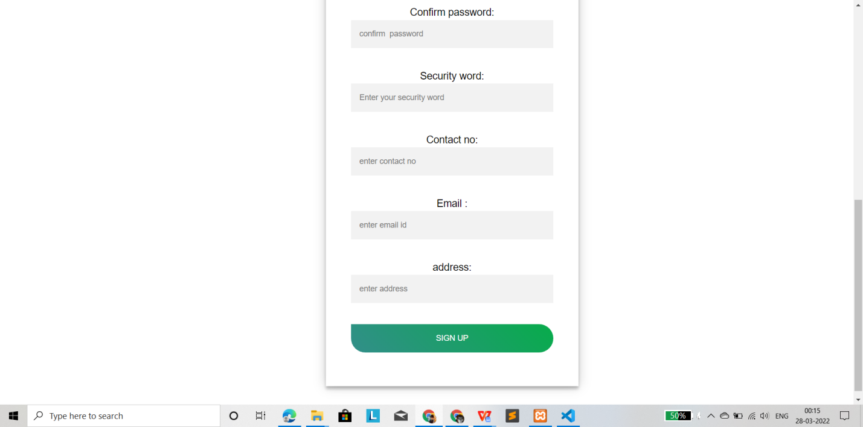

1. log in

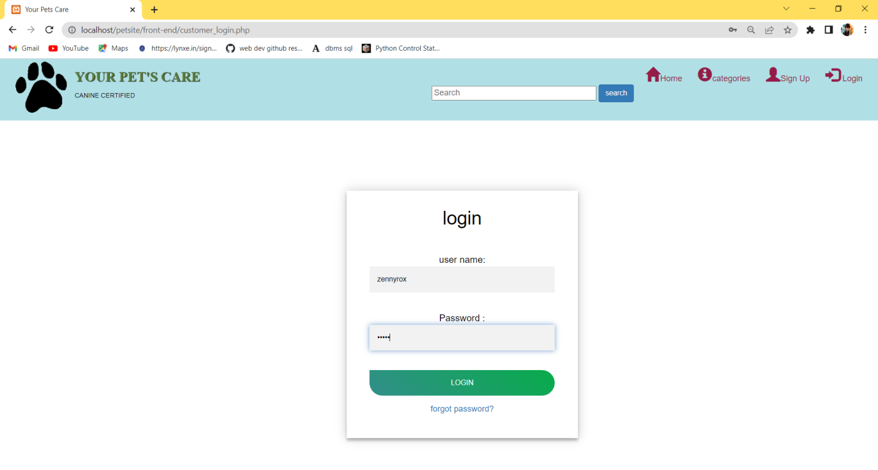

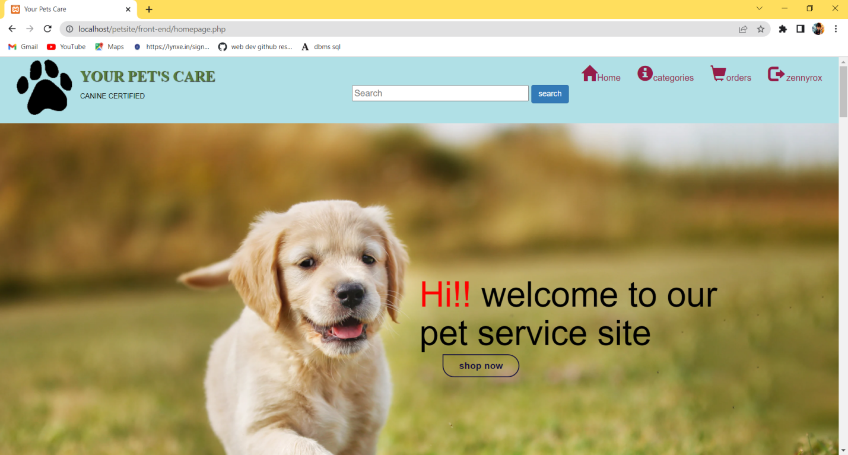

1. Search

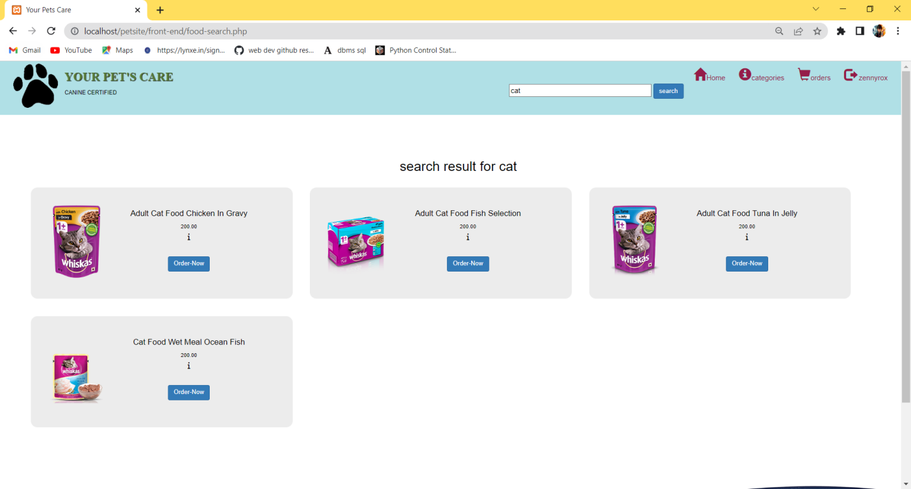

**Admin panel**

1. Admin log in

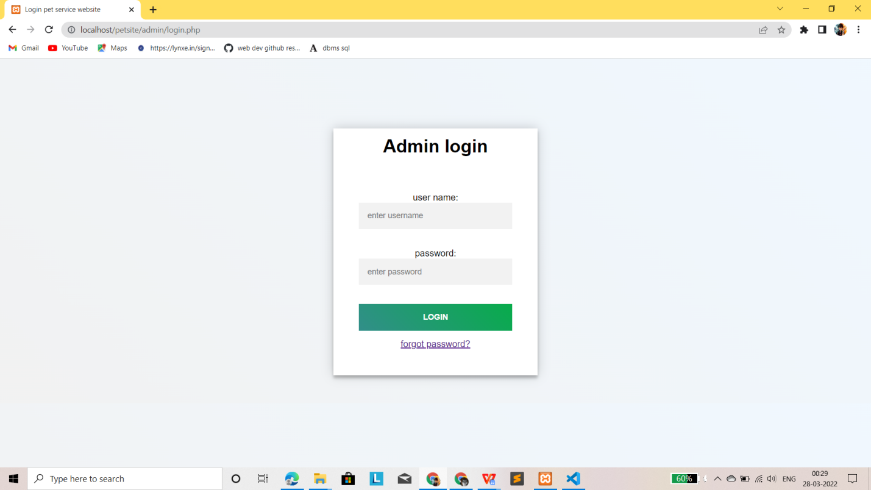

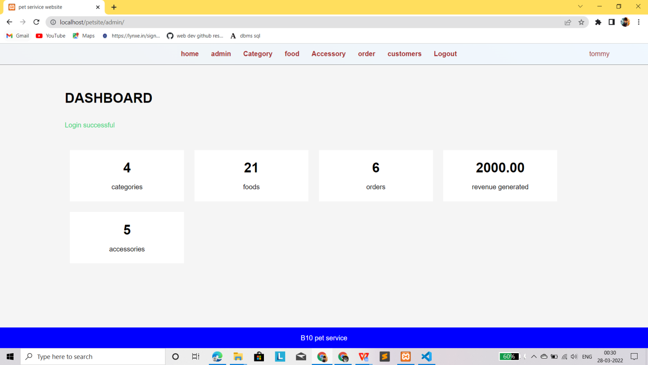

1. Manage Admins

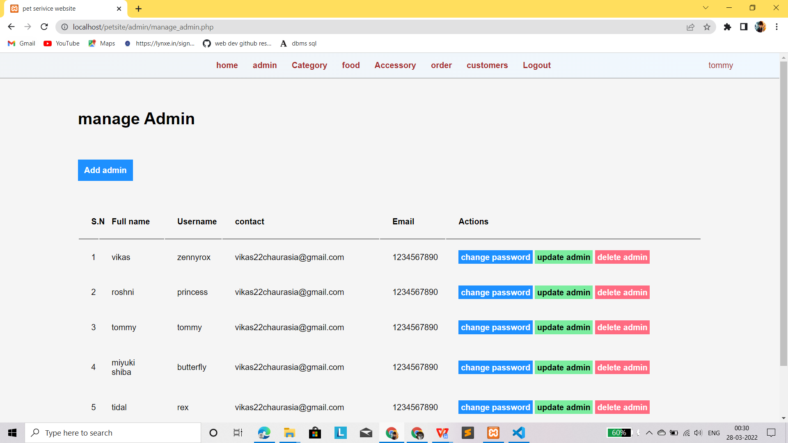

1. Category

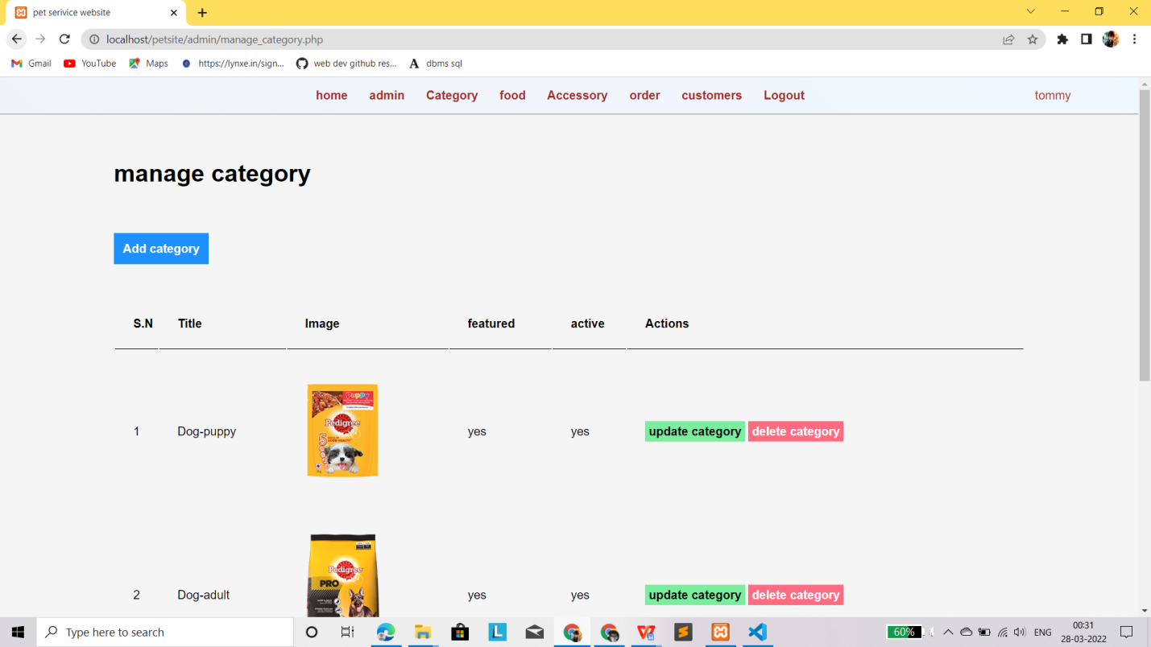

1. Add category

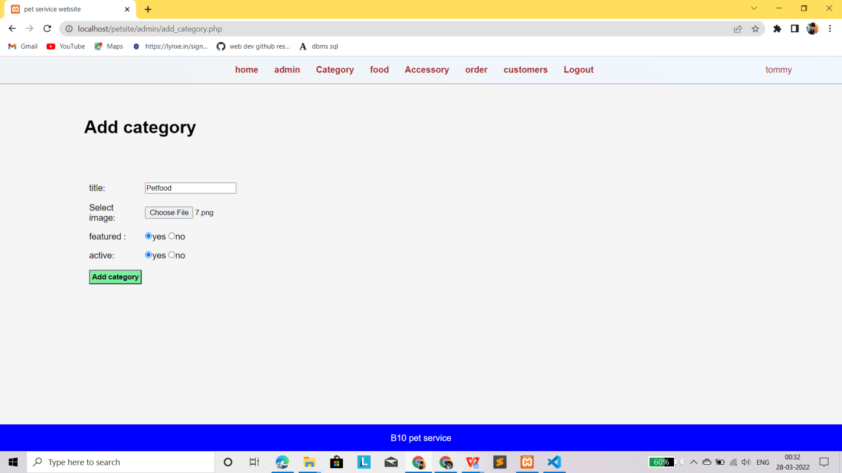

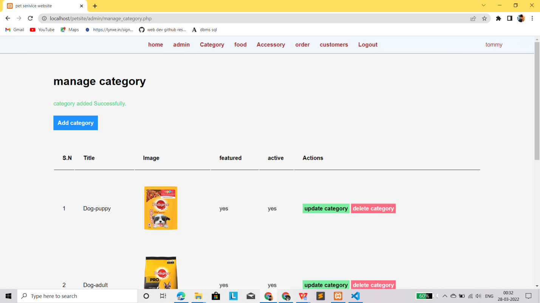

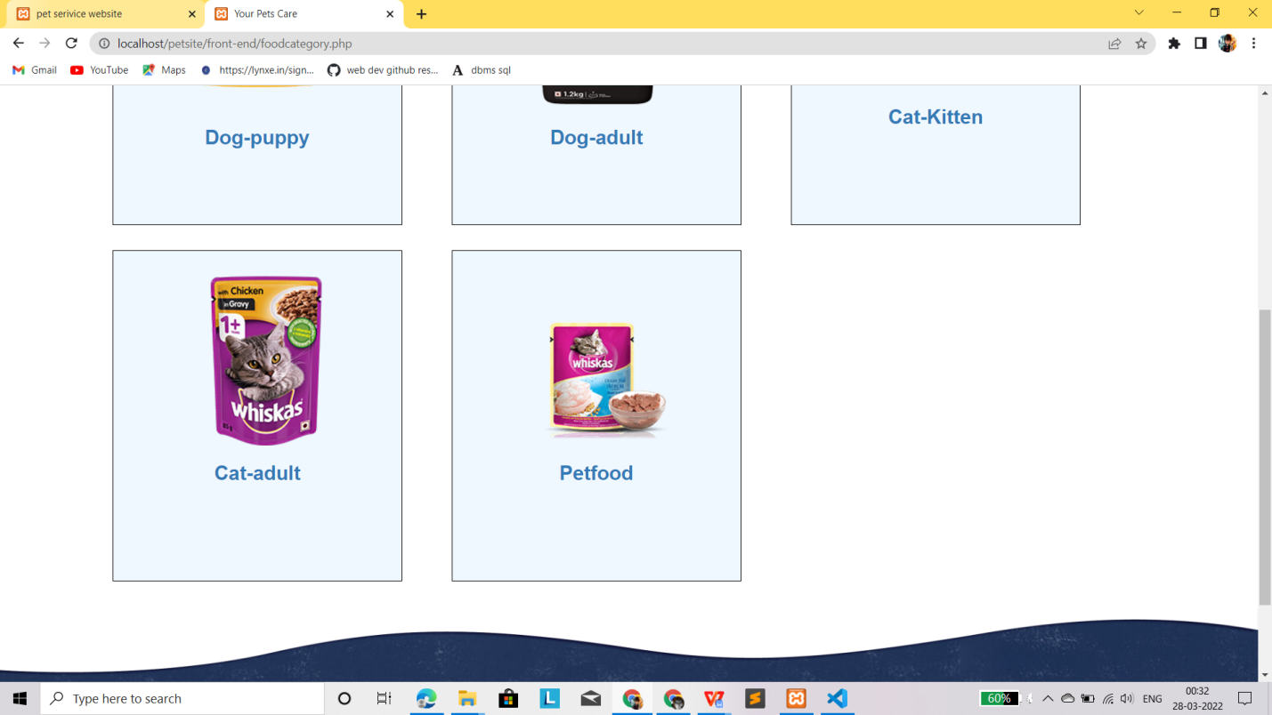

1. Manage order

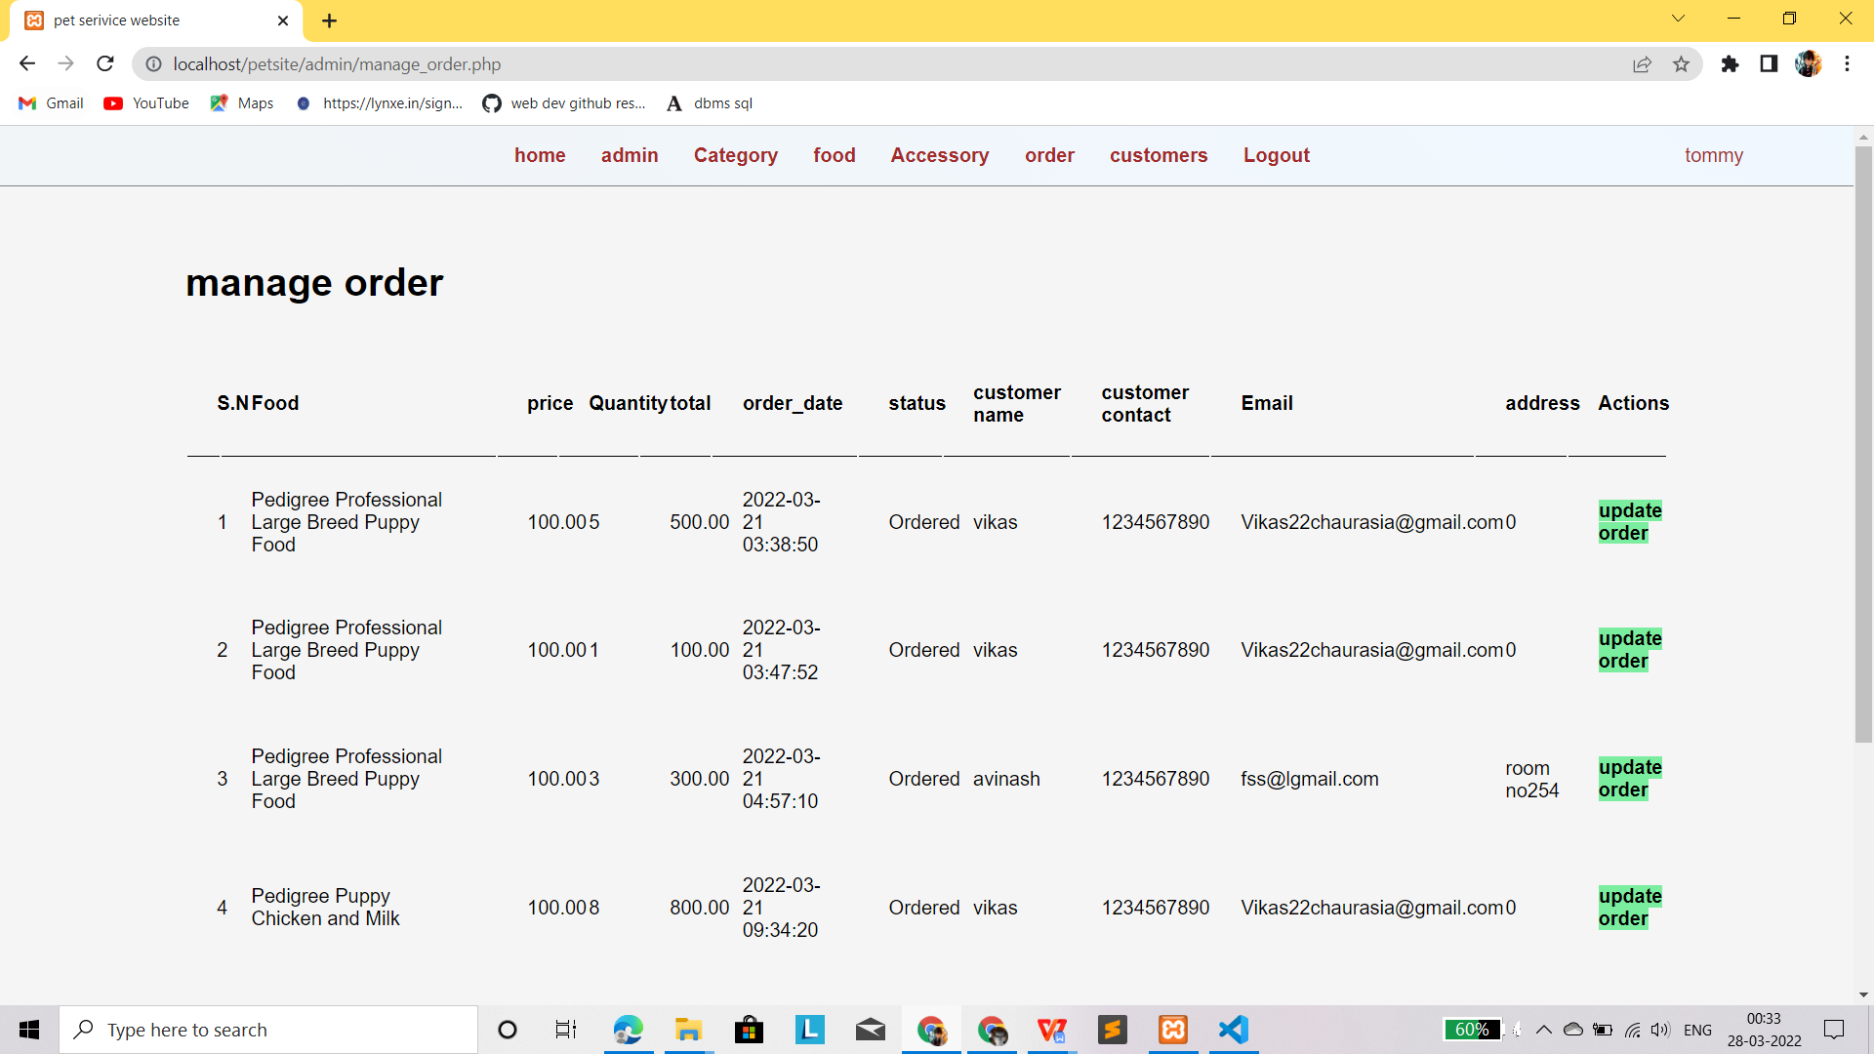

1. Customer details

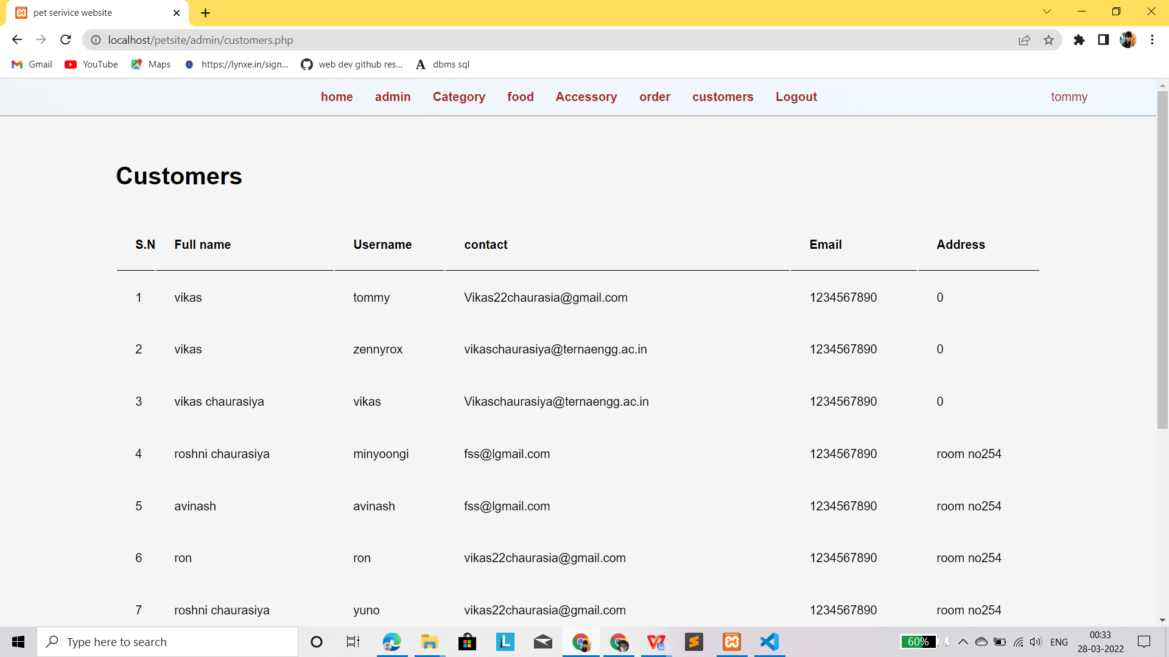

**Chapter 6**

**Conclusion and Future Scope**

**5.1** **Conclusion**

India has experienced double digit growth in its pet industry in last few years. Increasing awareness about pets and branded pet care products via internet is the major force behind this growth. According to Euromonitor International, a global firm with specialization in market research, the domestic product market of pets in India is expected to grow at a rate of 10-15 % in coming few years. The pet grooming market is expanding at a firm pace owing to the accessibility of frequent moveable pet groomers who deliver pet grooming activities as per the convenience of pet owners. The pet grooming market is expanding rapidly owing to the cost and convenience of the mobile groomer facilities. A recent market research focusing on the leading trends in pet products, has indicated that the worldwide pet products industry is highly influenced by a rising trend to treat pets as beloved family members. Expenditure on various spheres of pet lifestyle like grooming, health and indulgence are increasing. With increasing awareness about the good health and well-being of pet, pet healthcare industry is also expanding. Pet owners are not ready to compromise with the good health of their pets and routine vet visits are in trend.

**5.2 Future Scope**

We feel that our business will be successful and we will be able to meet the needs of our customer and give them a 100% satisfied service. Making the name of our business in the country is our target. We will put our best to make this website a successful one. We are looking forward to cover up all our expenses as mentioned in the financial part and achieve our goal in the proper way. Our website is not so big, we are very much hopeful that we will be successful one.

**References**

1. Allen K, Shykoff B, Izzo J (2001) Pet ownership, but not ace inhibitor therapy, blunts home blood pressure responses to mental stress. Hypertension 38: 815–820.

2. Wood L, Giles-Corti B, Bulsara M (2005) The pet connection: pets as a conduit for social capital?. Social Science and Medicine 61: 1159–1173. pmid:15970228 JASC: Journal of Applied Science and Computations Volume 5, Issue 11, November/2018 ISSN NO: 1076-5131 Page No:1171

3. Beck A, Meyers N (1996) Health enhancement and companion animal ownership. Annual Review of Public Health 17: 247–257. pmid:8724226

4. Allen K, Blascovich J (2002) Anger and Hostility Among Married Couple: Pet Dogs as Moderators of Cardiovascular Reactivity to Stress. Delta Society.

5. Qureshi AI, Memon MZ, Vazquez G, Suri MFK (2009) Cat ownership and the Risk of Fatal Cardiovascular Diseases. Results from the Second National Health and Nutrition Examination Study Mortality Follow-up Study. Journal of vascular and interventional neurology 2: 132. pmid:22518240

6. Edney A (1995) Companion animals and human health: an overview. [see comments]. Journal of the Royal Society of Medicine 88: 704p–708p. pmid:8786595

7. Friedmann E, Thomas S (1995) Pet ownership, social support, and one-year survival after acute myocardial infarction in the Cardiac Arrhythmia Suppression Trial (CAST). American Journal of Cardiology 76: 1213–1217. pmid:7502998

8. Cutt H, Knuiman M, Giles-Corti B (2008) Does getting a dog increase recreational walking? Int J Behav Nut Phys Act 5.

9. Grand View Research (2018), “Pet Care Market Size, Share and Trends Analysis report by pet type(dog, cat, fish, bird), by products, competitive landscape, and segment forecasts, 2018-2015”, Retrieved Mar 2018 from https://www.grandviewresearch.com/industry-analysis/pet-care-market